**Contents**

Scanning Guide

August 2013

Riley Hun, Environmental Student

1. Introduction 3

2. Pre-Scanning Process 3

2.1. Sorting Process 4

3. Verification Process 5

4. Scanning Process 5

4.1. Scanning photographs 6

4.2. Scanning sticky notes 7

4.4. Scanning oversized documents 8

4.5. Auto-detect versus manually changing the page size 10

4.6. Procedure for Duplicate pages 10

5. Review Scan and Quality Control 10

6. Re-filing 11

6.1. Re-filing and sorting booklets, binders and duotangs 12

7. Spot-checking your work 12

8. E-filing 13

9. Tracking 13

10. Additional Information 14

10.1. Cleaning the Scanner 14

10.2. Errors and Technical Glitches 15

# 1. Introduction

Perhaps deceptively, scanning is actually a more complex process than you would initially perceive. When I first started scanning, I thought it was going to be a walk-in-the park because on the surface, it did not seem like a labor intensive task. Rather, it presents its own kind of unique challenge. That is, it gradually gets more mentally daunting especially when you have to efficiently scan a box that is tightly crammed with a plethora of folders, many of which contain photographs, different sized documents, and maps. I have put together this training manual to help ease yourself into understanding the whole scanning process on a more intelligible level and also help you avoid some nasty oversights that I made when I was a scanner. Take note that scanning is essentially a step by step process that you must strictly adhere to in order to avoid making any errors. Since all of these scanned files and boxes are sent to Library and Archives Canada, it is of paramount importance that you scan everything to perfection. It is my hope that this manual will be a valuable resource in helping you familiarize yourself with some tried and true scanning techniques that I adopted from my mentors and also developed through personal experience. In time, you will eventually develop your very own scanning techniques. Lastly, I wish you the best of luck and I hope you find scanning as rewarding as I did.

# 2. Pre-Scanning Process

Information Services (help desk) should have downloaded the HP Scanjet N9120 scanning software to your desktop. If not, follow the instructions contained in the Getting Started Guide to download the software yourself. Once downloaded, you can initialize your scanning profile settings. Double click HP Smart Document Scan on your desktop to bring up a menu (refer to Image 2.1) for your profile settings. Click ‘Create new profile’ and enter in your profile name (first and last name). Now, go to the ‘Scan Settings’ tab. For ‘Image Options’, make sure the resolution is 300 ppi and the mode is 24-bit color. For ‘Page Size’, scroll up to ‘Auto detect size’. Be sure to verify that the ‘Page layout’ is portrait, duplex (2-sided, book) and top edge first. Now switch over to the ‘Image Processing’ tab, and check off straighten page content and delete blank pages under the ‘Adjust each Scanned Page’ and ‘Adjust Scanned Document’ side-bars, respectively. Lastly, go to ‘Destinations’ and ensure that all scanned documents are automatically **OCRed**. Click ‘Send To’ to change the directory for which your scanned documents are saved to.

|  |  |
| --- | --- |
| *Image 2.1 Scanning Profile Menu* | *Image 2.2 Configuring Scanner Properties* |
| Main tab | Side-bar tabs |

## 2.1. Sorting Process

As the most time consuming part, sorting requires a great amount of patience. To that end, it is easy to fall prey to the monotony of sorting unless you pace yourself and build up momentum. Start with the thinner folders first and then work your way up to the thicker and more complicated ones. By doing so, you are essentially warming up your brain, much like stretching before you run a marathon. Remember, you are free to be selective about which folders you want to scan first; you do not have to scan folders following the order they are packed in the box.

If the documents contained in a file folder are split between the left and right sides of the folder, start with the left side first. All of these documents should be sorted according to date, in which later dates are at the front and earlier dates are near the back of the folder. If a document contains more than one date, use the later one, as a later date would imply that that particular document has been revised. Thus, always look at the date associated with the most recently revised version of a document. Tread cautiously though because some dates are associated with a document’s letterhead or layout and not in any way relevant to the day the actual content was conceived.

*Helpful hint #1: What to do with undated documents*

Some documents may be undated or have their dates cut off. You can look at the dates of surrounding documents to give you a clue as to what the correct date is. Obscure documents that have absolutely no traces of a date go at the end of the file folder.

File folders will contain stapled documents consisting of multiple pages. To avoid any impending confusion during the sorting process, make sure to mark down the page number on the top right hand corner of each page (i.e. page 1 of n, where n is the total numbers of pages) before removing the staple. Since most stapled documents are not ordered by date before they are stapled, you may be unable perfectly sort all documents within their respective file folders. As such, the front cover page is to be treated as the main document, and all other subsequent pages are supporting documents. In a nutshell, think of stapled multi-paged documents as packages. The date of the first page of this package is the one you should use when sorting.

# 3. Verification Process

Double-check that all the pages are correctly ordered according to date range. While flipping through each page, remove any sticky notes you can find. Most sticky notes are not significantly important, but if there are any interesting facts written on them, you can place them on the back of the page. Some of the larger sticky notes may show actual correspondence or contain valuable information that greatly pertains to the documents they are attached to. If this is the case, you must scan these sticky notes. Scan all sticky notes separately from the document they are attached to, unless the sticky notes are used as labels for a map or plan.

# 4. Scanning Process

After completing the monotonous sorting process, you can finally let the scanner do some of the work for you. But before you load the pages onto the scanner and click the scan button, make sure you count the total number of pages per batch you put in.

Pages should be placed on the feeder face side up, with the top of the page gently resting on the scanner’s sensor. It is highly recommended that you place 20 to 50 papers on the feeder at a time to avoid jamming. Also extend the tray to hold the scanned pages in place; anything past legal size will likely fall out.

*Image 4.1 Placing pages onto the scanner’s feeder*

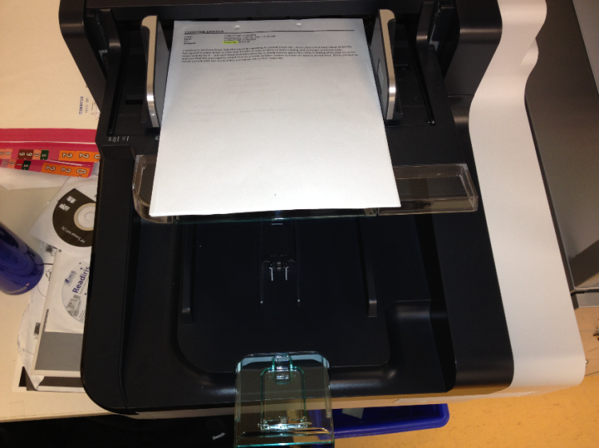

Extend tray

Insert pages onto the feeder face

side-up with the top edge touching the sensor

*Helpful hint #2: How to avoid jamming*

Remember to fan the papers out otherwise the scanner will either jam or grab multiple pages at a time. Stacks of pages that are folded multiple times tend to get stuck to one another when going through the feeder. To remedy this problem, you can either place the pages on the **flatbed** and scan them this way or scan them one at a time using the feeder. The scanner is intelligent enough to know when it has grabbed multiple pages. If you leave a sticky note on a page, it might detect this as multiple pages.

You should be double-sided scanning when using the feeder. Doing so relieves some of the hassle of looking through a batch of pages to see if there is content on only one side of the page. Keep in mind that the blank-page remover that you set up in the pre-scanning process will delete most of the blank pages, and you can also adjust the strictness of the blank page remover. You can go ahead and click scan now.

*Helpful hint #3: Overseeing your scanning progress*

Count the number of pages you put in *while* scanning. You can easily keep a close eye on the pages you are scanning using the scanner’s **thumbnail gallery***.* In this way, it is easier to verify that the same amount of pages you put in have been scanned. Make sure to multiply the number of pages you count by 2 since you are double-sided scanning.

## 4.1. Scanning photographs

There are two methods you can follow when scanning photographs.

Method 1: You can scan individual photographs using the flatbed, in which each photograph is scanned separately as its own page. If there is writing on the backs of these photographs, you must also scan them as separate pages.

Method 2: all related photographs from the same date can be scanned onto one page. In this way, a maximum of 8 photographs can fit onto the flatbed. In order to fully utilize the entire space of the flatbed, you must temporarily reconfigure the page size to maximum. To do this, double click on the thumbnail of any of the pages you have scanned thus far. Then go to ‘rescan settings’, which will allow you to alter the page size. When asked whether or not you want to ‘apply these changes to the profile’, press No.

|  |  |
| --- | --- |
| *Image 4.2 Re-Scanning Menu* | *Image 4.3 Using Typewriter* |
|  | C:\Users\rzh\Desktop\image.png  Text on the back of photo |

If there is writing on the back of a photograph, you normally would have to scan the back as a separate page. Alternatively, you have the option of using Adobe Acrobat’s Typewriter function to manually write out the text onto the photos after they have been saved as a PDF file. In reference to image 2.2, the typewriter function can be found under Tools. Then use your mouse to click on the area of the photograph you want your text to appear on.

## 4.2. Scanning sticky notes

To scan a sticky note that documents important details, place it on the flatbed and once scanned, double click the image thumbnail of the scanned page to bring up an options menu. Drag your mouse until the red square ensnares the whole image and then click the crop icon to crop the sticky note so that it fits the entire page. Sticky notes that document extraneous information do not have to be scanned. Business cards and small pamphlets can be scanned in the same way as sticky notes.

|  |  |
| --- | --- |
| *Image 4.4 Types of Sticky Notes* | *Image 4.5 Cropping Menu* |
| The sticky note on the right should be discarded, while the one on the left should be scanned | Crop icon  Red outline indicates that the entire sticky note has been captured and can now be cropped |

Though this is a rare occurrence, you may encounter a CD or floppy disk in a file folder, in which case you need to extract the important files that they digitally store. Email Information Services (Service.Desk@portmetrovancouver.com) to request that they help you extract the data from these aforementioned physical storage mediums. Do not extract the data without permission first. Not only is there no floppy disk drive on your computer, but you may inadvertently infect the network with a virus. Once Information Services helps you retrieve the stored data, use the flatbed to scan the physical representation of the CD or floppy disk as you normally would any other page. The CD must be sorted appropriately according to date range like any other page in the file folder. After saving the scanned pages, insert the data (usually in PDF format) directly below the scanned image of the CD or floppy disk in the order they appear on the CD or floppy disk. See 4.4. Scanning oversized documents for how to insert pages.

## 4.4. Scanning oversized documents

Due to the limited page size capacity of your regular scanner, you will have to scan oversized maps or plans separately using the plotter machine. Before scanning, attach a sticker label to the backs of each oversized document, and indicate the file folder carrying the plan or map, the date of the map, and the title or description of the map. If the oversized document is attached to another document, you should also include the title of that document on the sticker label.

Since maps and plans are scanned using a different machine and thus saved as separate PDF files, you will need to make use of marker pages. Using your regular scanner, scan a colored page to act as the marker page. The purpose of the marker page is to designate the placement of an oversized document amongst the rest of the documents from a particular file folder. Keep in mind that the order of everything you scan must exactly mirror the order of the physical copies in their respective file folder. After saving everything you have scanned, you can replace the marker pages with the scanned oversized documents. To do this, go to the pages tab and then right click on the marker page thumbnail. This should open up a menu consisting of different options, including ‘insert page’ and ‘replace page’. Click ‘replace page’ to swap a marker page with its corresponding map or plan.

*Image 4.1 Set-up for inserting oversized documents*

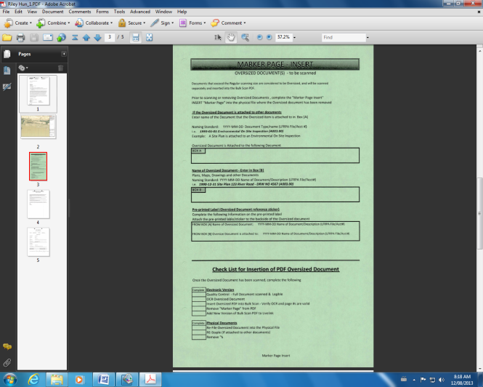

Replace marker page with oversized document

When inserting a map or plan into the plotter, make sure it is face-side down and the top edge touches the feeder. Carefully insert it in as straight as possible otherwise the scanned document will be lop-sided. As you slowly insert the oversized document, the plotter will automatically grab it. Before clicking scan, verify that the plotter machine is on scan mode (not copy mode) and settings are as follows: ‘map’ or ‘CAD*’ for type of original and ‘Auto’ for scan resolution and size. Once all the settings are correct (see figure 4.5), press the scan icon and then TOTAL*. Your scanned oversized document will be saved to the W:// drive in the Engineering Scanner folder. Slide the PDF file of the scanned oversized document over to your desktop and delete the file from the W:// drive afterwards. When you open the PDF file for the oversized document, make sure you remember to have it OCRed by going to ‘document’ and then clicking ‘OCR Text Recognition’. Also clarify that the document is sufficiently visible. If not, adjust the contrast and brightness and re-scan the document. It is important to note that oversized documents that exceed the boundary dimensions allowed by the plotter have to be inserted with the left or right edge touching the feeder (rotated 90 degrees and then inserted). The downside is that if you do this, the scanned document cannot be OCRed. After scanning the oversized document, release the map or plan from the plotter by pressing on the down arrow key.

*Image 4.6 Scanning oversized documents Image 4.7 Configuring plotter settings*

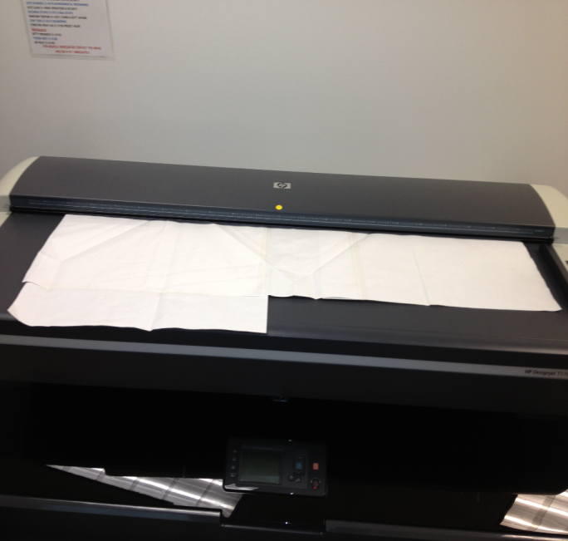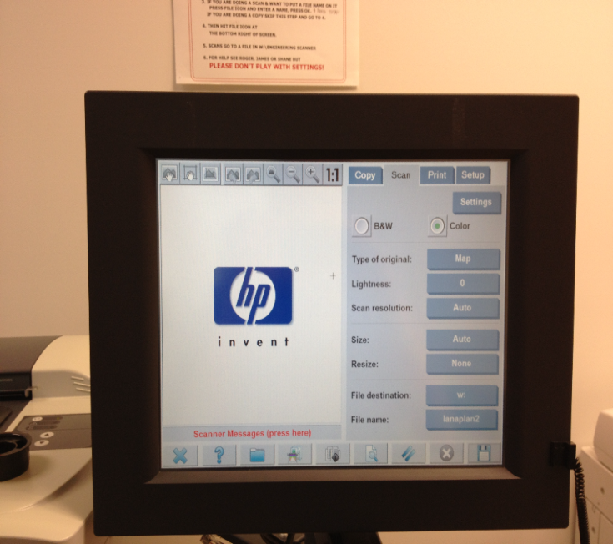

Scan icon

*Helpful tip #4: How to re-use marker pages*

If you want to save some trees, you do not have to permanently use a marker page by writing out the map’s title and the associated file folder information. Instead, when prompted by the plotter machine to name the document, designate each oversized document as they appear in the file folder (after being sorted) according to ascending numerical order (i.e. rh1, rh2, etc.). After scanning the oversized document, you can drag the scanned PDF file over to your desktop. You should align each scanned oversized document according to numerical order. When swapping out the marker pages with the scanned oversized document, it should be a seamless process because the first colored marker page that appears is to be replaced by the first oversized document-PDF file that appears on your desktop.

## 4.5. Auto-detect versus manually changing the page size

Auto-detect is one of the most valuable assets of your scanner because it will allow you to insert stacks of different sized pages (usually a mixture of legal and letter) onto the feeder to be scanned. While auto-detect is more convenient than manually changing the page size, it does have its shortcomings. Most prominently, auto-detect captures the hole punches of scanned pages, which appear as black circles. Additionally, if a corner of a page is accidentally folded, the auto-detect feature will scan this. Since auto-detect is more prone to capturing these page discrepancies, what should be a blank page may not be filtered out by your scanner’s blank page deleter. Thus quality control is important because you cannot overly rely on your blank page deleter to effectively eliminate all the blank pages.

The greatest advantage manually changing the page size has over auto-detect is that pages are scanned at a much faster rate and less likely to jam. To that end, for file folders that contain documents of the same size, you may find that it is best to abandon auto-detect. To manually reconfigure the page size settings each time you insert a different sized page, double click on the thumbnail of any page you have scanned thus far. Then go to ‘rescan settings’ to switch between letter and legal sizes.

## 4.6. Procedure for Duplicate pages

If you want to play it safe, you can scan everything you find in each file folder. However, you should be aware that you do not have to scan an exact copy of the same page. If you choose to do this, you should make sure that the pages are in fact EXACT copies. If any 2 pages are even slightly different (i.e. highlighted words, tick marks, words are changed) you must scan both pages. For copies of the same page, stick a copy tab or sticky note with “duplicate” written on it on the copy, and then paper clip the copies to the original page.

# 5. Review Scan and Quality Control

Using the scanner’s thumbnail gallery, make sure all blank pages are deleted, no pages were missed out and the scanner did not delete any pages with writing on them (including photographs and oversized documents). Always remember that we want to scan everything as they appear in the file folder. If the visibility of a page that is scanned is poor, you can play around with the brightness and contrast settings and then re-scan the page. Additionally, you can adjust the strictness of the scanner’s blank page delete such that a page has to be 95% white space to be deleted. Once you have finished scanning all the documents contained in their respective file folder, before you click save, make sure the total number of pages scanned equals the number of physical pages in the file folder.

*Helpful tip #5: How to quickly verify that everything has been scanned*

Before you put a stack of pages onto the feeder, count the number of pages and see that the number of pages scanned correctly corresponds to the amount you put onto the feeder. Your scanner will tell you the total number of pages it has scanned. It should also be relatively easy to count the number of pages you put in especially if a lot of the documents were stapled together. Remember, you marked each page prior to stapling. So you just have to do a little bit of addition in your head. If you prefer, you can count while scanning batch by batch. Just make sure to multiply your count by 2 since you will be double-sided scanning.

If you are not using auto-detect, check that none of the scanned pages are cut off when switching between letter and legal page size. After thoroughly navigating through the thumbnail gallery and making any necessary changes, you can go ahead and click save. The scanned pages will be sent to the destination folder that you designated when you were configuring your profile settings. Save the bulk scan using the following naming standard: date company name (date range YYYY-MM-DD) Box number – Barcode. If no company name is provided on the folder, search through the pages of the folder and see if there is some trace of a company name through reading the correspondence letters. It usually takes 5 to 15 minutes to save the bulk scan depending on the number of pages in the file folder.

*Image 5.1 Saving PDF file and sending to destination folder*

# 

thumbnail images of scanned pages

scanned files are sent to specified destination folder

click save

# 6. Re-filing

While you are waiting for the pages to scan, you can re-file the physical pages into their file folder according to the order they were scanned. Make sure the left side of the folder is re-filed separately from the right side of the folder.

*Helpful tip #6: Cycling through the scanning process*

Do not scan both sides of a file folder at the same time. To avoid confusion, you should start the entire scanning process with the left-side first and then once you have finished scanning every page from the left-side, you can move on to the right side. So in a nutshell, sort, scan and re-file the left-hand side and then repeat again for the right-hand side of the folder.

Re-staple any previously stapled multi-paged document. It should be quite easy to tell which pages were originally stapled because you marked the pages as 1 of n, 2 of n, 3 of n, etc. Hole-punch any loose pages so they can be neatly inserted into the file folder. Photographs can be paper-clipped to the page that comes after it, or you can use the metal hoops from a black binder clip to attach the photograph to the metal fasteners within the file folder. Incidentally, any oversized documents that are not hole-punched can be re-filed into the file folder using these black binder clips.

## 

## 6.1. Re-filing and sorting booklets, binders and duotangs

While most multi-paged documents are stapled together, you will eventually encounter reports in booklet format bound by rings, coils or combs. To remove the pages out of a comb, you need to head out over to the shed and use a machine that locks the comb in place and then spreads the comb apart. The booklet should be front page facing down while placed on the machine. Then pull down on the lever to have the comb spread open. Pages from the booklet can now be removed batch by batch. Gently remove the pages from the comb and try not to rub the comb against the holes on the pages otherwise the pages will stick together, resulting in more paper jams when you scan these pages. Pages can be re-inserted back into the comb in a similar way. To remove the pages from booklets that are bound by spiral coils, you can either patiently twist the coil until the pages are free or pry the coil out and then use a stapler to re-staple the booklet.

Keep in mind that you are to treat booklets, duotangs and binders as a package, and as such, keep the original order of the pages despite an incorrect date ordering. You may choose not to scan any divider pages if they are present. If your file folder has two or more booklets in a row, then you do not have to scan the backs of these booklets (unless there is writing on the backs), since the front cover of a booklet will differentiate itself from another. Some booklets or binders will contain plastic pouches carrying oversized documents; when you have finished scanning these documents, they should be returned to their respective pouches.

# 7. Spot-checking your work

Basically, this is similar to the quality control process. The only difference now is that you are checking your work as a saved PDF file. Open up the PDF file from the directory it was sent to and click on the pages icon to bring up a thumbnail gallery of all the scanned pages. If the pages icon does not appear, go to view and then navigation panel. From this menu, click on pages and then dock navigation panel. From the pages navigation panel, you can scroll down and right click on any of the pages to bring up a menu that lets you delete or rotate pages, swap marker pages with scanned oversized documents, or insert any pages as you see necessary.

*Image 7.1 Using the pages navigation panel*

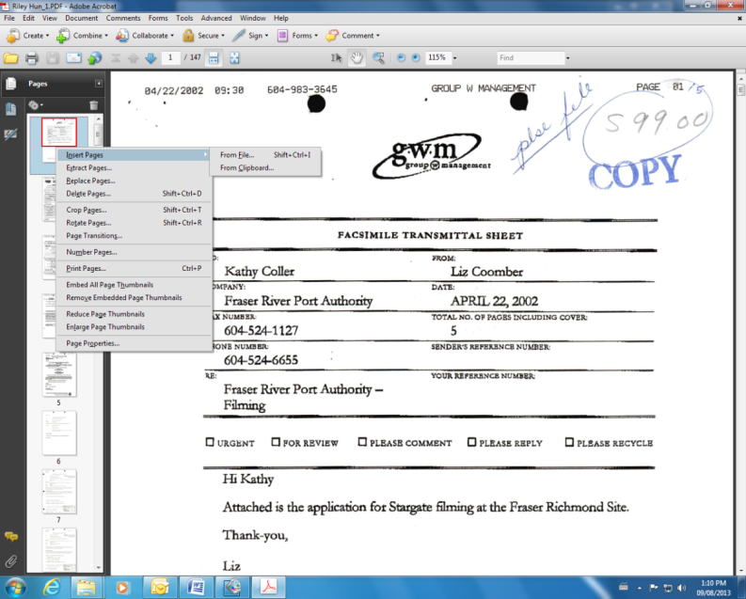

Click pages icon to display thumbnail gallery for scanned pages

Menu for adding changes to scanned pages

Don’t over-use the pages navigation panel. It can be difficult to see the entirety of the page since each page appears as a very small thumbnail image. Instead, go to view and execute full screen mode to properly spot-check your work. Full screen mode will allow you to flip through the pages a lot faster. The right arrow key on your keyboard will let you flip to the next page and the left arrow key lets you go back. While flipping through these digital pages, check and see that the physical copies from the file folder have been perfectly scanned, and that all pages are intact.

After verifying that all the pages from the file folder have been scanned, you can now insert page numbering into the PDF file by going to the document menu, clicking header and footer, and then pressing add. Under center footer text, type out <<1>> and decrease the bottom margin to 0.2. Also note that if you want to start the page numbering at a number other than 1, you can click on start page and date format and then change the start page number.

# 8. E-filing

Once the PDF file has been renamed following the naming standard, you can file it into Livelink. You can open up Livelink from your desktop by clicking on Enterprise Connect or from a web browser by typing in the URL http://ll. From Livelink, go to the directory where you are to transfer the PDF files to (this directory should be added as a favourite). To transfer the scanned pages to Livelink, simply drag the PDF file from your desktop and drop it into the designated Livelink directory or folder. When prompted to verify the name of the document, click OK (see image 8.1).

*Image 8.1 Transferring a PDF file to Livelink*

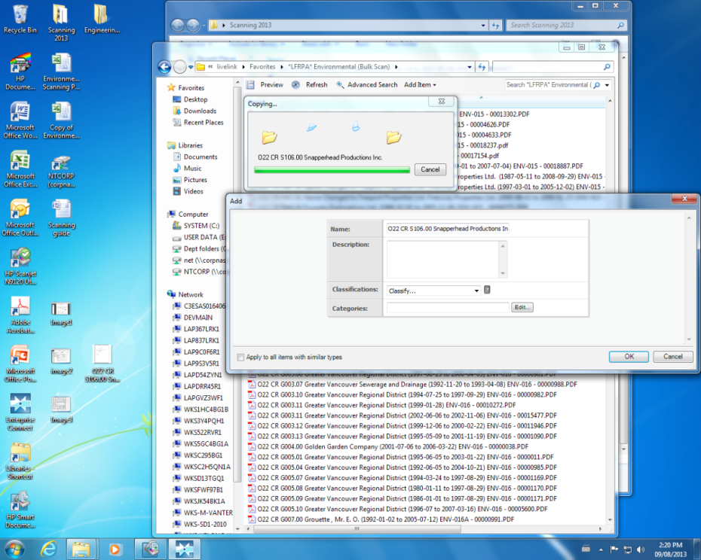

Livelink folder the file is being transferred to

Loading screen showing that the file is being transferred to Livelink

Verify that the name of the PDF file is correct and then click OK

# 9. Tracking

Retrieve the tracking sheet which lists all the file folders contained in each box, and write down the date range of the content in each folder, the date you finished scanning the pages from the folder, and lastly check off with a tick-mark. It is better if you do this after you finish scanning each file folder so you know which file folders are missing from the box and which ones you still need to complete. When that is done you should stamp ‘scanned’ on the front of the file folder. I typically stamp the label since some file folders are glossy and the stamp will likely smudge. Place a flat surface underneath the front of the file folder before you stamp. When all the file folders have been scanned and spot-checked, you can file them back into their respective boxes in the order they are listed on the tracking sheet. Be sure to stamp ‘scanned’ on the boxes as well.

|  |  |
| --- | --- |
| *Helpful tip #7: Boxing without the use of tape*  When boxing, fold 3 of the four flaps of the box on top of one another and then slide the fourth flap underneath the flaps. This will enable you to package the boxes without the need of using tape. Refer to Image 9.1 to see what the closed box looks like. | *Image 9.1 Closed box* |

Print out the cover sheet for the tracking sheet and write down the box number, your name, the number of files you scanned, date of completion and start date. Also make note of any discrepancies you find for each box on the cover sheet. Recalling from my own personal experience, you will likely be unable to OCR some maps or plans, and you may also encounter boxes with missing folders. Make sure to include the document description, file name and barcode number when writing down any discrepancies. Staple the cover sheet to the tracking sheet and attach to its respective box. Refer to image 9.2 to see an example of a proper cover sheet.

*Image 9.2 Cover sheet with discrepancies written out*

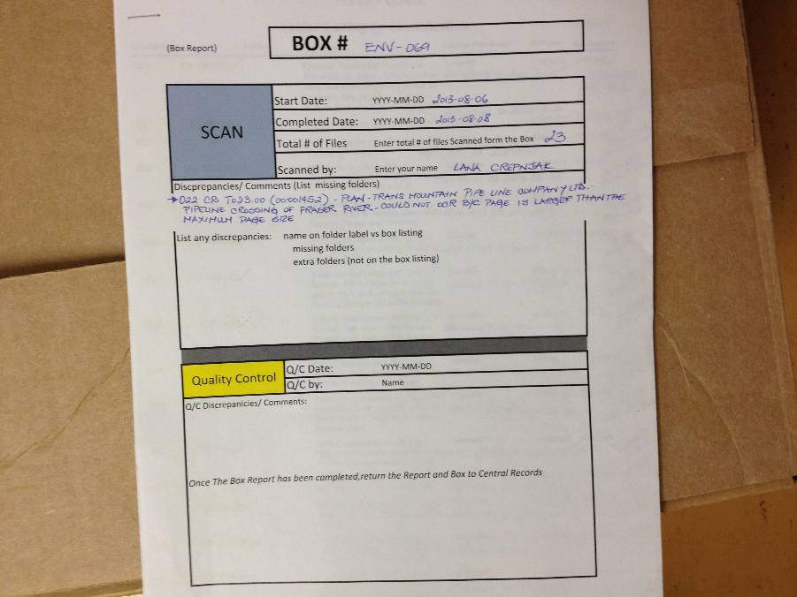

# 10. Additional Information

## 10.1. Cleaning the Scanner

Scanning tens of thousands of pages will eventually make your scanner malfunction. If your scanner is not cleaned adequately on a regular basis, you may notice a vertical red line running down the pages you have scanned. To get rid of this red line, you need to grab a scanner cleaning kit, which you can acquire from Central Records upon request. Once you have the kit on hand, gently pour a bit of cleaning liquid on a piece of cloth and then gently scrub the rollers free of ink. Also make sure you get rid of any paper bits on the feeder.

## 10.2. Errors and Technical Glitches

The most infuriating technical error you could encounter is a scanner or software crash. This usually happens when you try to save the pages that you have scanned. While in the middle of saving, an error message will pop up (see images 10.1 and 10.2), and consequently, the software program will terminate and all your work will be lost. Needless to say, tread cautiously and scan in smaller batches. Saving greater than 500 pages will have a higher probability of initiating an error. This has happened to me several times and quite often too. But after re-installing the software, the frequency of this error quickly diminished.

*Image 10.1 Scanner Error Example 1 Image 10.2 Scanner Error Example 2*

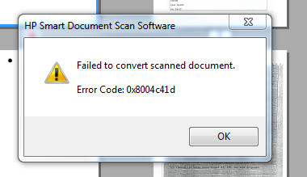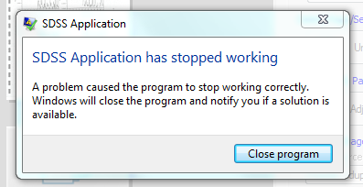

While saving your scanned documents in smaller batches is always a safer bet, it does create a new problem. When you combine 2 or more PDF files, Adobe Acrobat will prevent you from inserting page numbering. If this is the case, you will have to detail the number of pages in the file name (i.e. date company name (date range YYYY-MM-DD) Box number – Barcode p.1 to p. n)

Another annoying disruption you may encounter is your scanner freezing, disabling you from scanning any pages. To remedy this problem, you will need to re-install the software. Go to your desktop’s control panel and uninstall the HP Scanjet program and then follow the instructions from the manual to re-install the software. You might need to ask for permission from IS to do so.